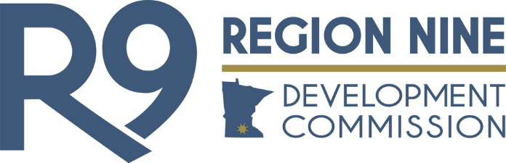

BOARD OF DIRECTORS MEETING

Meeting Minutes
November 13, 2024

I. CALL TO ORDER

Secretary Branstad, serving as Chair, called the meeting to order at 4:23 p.m. at RNDC.

II. ROLL CALL

MEMBERS PRESENT: Jim Branstad, Marie Dranttel, Lyle Femrite, Christian Lilienthal, Steve Rohlfing, Phil Schafer, Rob Wilkening

MEMBERS EXCUSED: Andrea Boettger, Mike Laven

OTHERS PRESENT: Ky Battern, Jessica Beyer, Nathan George, Nicole Griensewic, Bill Groskreutz, Sarah Janovsky

There was a quorum.

III. APPROVAL OF CONSENT AGENDA

Femrite moved to approve the consent agenda. Dranttel seconded. Motion carried.

IV. INFORMATION/DISCUSSION ITEMS

- Finance Directors Report
Finance Director Ky Battern provided an update, stating that he is finalizing the succession plan for his position. He also noted that the auditors will attend next month's board meeting to present the final audit figures.

- Chair’s Report
Secretary Branstad will be participating in a delegation with the University of Minnesota to North Rhine-Westphalia, Germany, in December. The delegation's primary focus is on reducing waste sent to landfills.

- Executive Director’s Report
The delegation from the Aachen region of Germany has reached out to RNDC to further develop contacts and continue follow-ups after their recent visit.

Nicole and Jessica will have a follow-up meeting with the Mankato Area Foundation to discuss hiring a position focused on addressing food insecurity and recovery, funded by a private donor.
RNDC also plans to hire a full-time transportation position, funded by the Federal Department of Transit's Safe Streets and Roads for All grant.

Nicole and Chair Laven, along with other MADO Directors, recently attended the NADO Annual Training Conference. Commissioners Borchert and Hilpipre recently participated in a delegation visit to Denmark. RNDC will follow up with them this week and create a plan for them to present to the Commission in January.

Nicole recently appeared alongside Commissioner Borchert on KTOE’s Talk of the Town, resulting in her securing a recurring monthly segment on the show. Additionally, RNDC will partner with True Facade to create marketing outreach videos.

Sabri Fair was recognized in Minnesota Valley Business as part of the "Emerging Leadership: Leaders Under 40" feature.

A recap of the Americas Competitiveness Exchange on Innovation and Entrepreneurship, along with videos, will be shared with commissioners. Nicole updated on her follow-up efforts, including meetings with the Minnesota Department of Agriculture (MDA), President Inch of MSU, the Center for Transportation Studies, and other stakeholders related to the ACE Armenia exchange.

- Board Portal
Communications Specialist Nathan George presented recent updates he plans to implement to improve the portal's usability and accessibility for RNDC board members.

V. OTHER BUSINESS

- Commissioner Updates
Commissioners shared updates from their communities. In November's election, Femrite, Hilpipre, and Milbrath were not re-elected as township representatives, an unusual outcome. The board thanked Femrite for his service to RNDC during his tenure.

Reminder: The December Board of Directors meeting is a week early, December 4, 2024, due to the AMC Conference.

- Meeting Evaluations

VI. ADJOURNMENT

Schafer moved to adjourn. Femrite seconded. Motion carried.

The meeting was adjourned at 5:46 p.m.

_________________________________________ _________________________________________
Mike Laven, Chair Jim Branstad, Secretary

